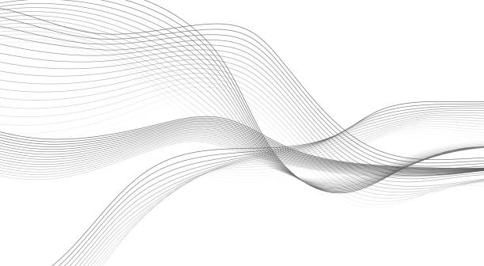
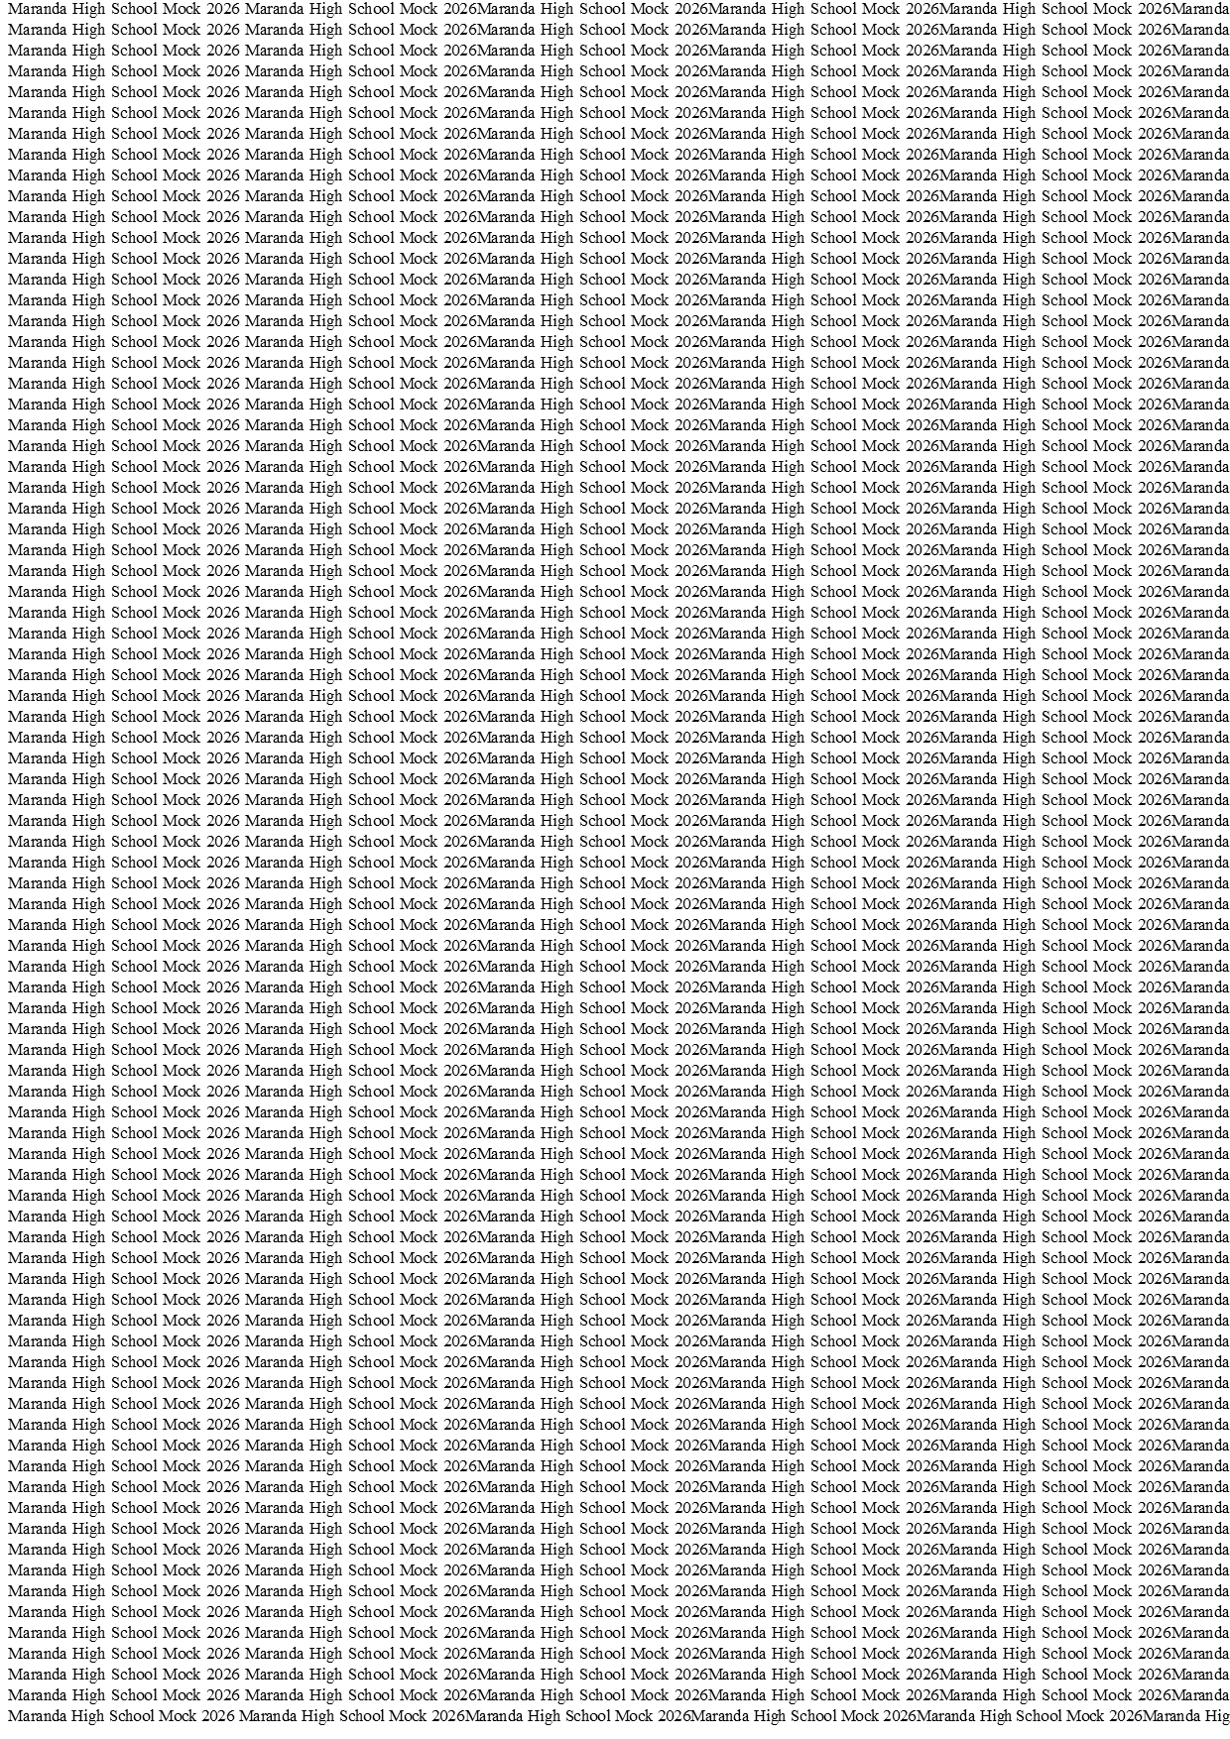



MARANDA HIGH SCHOOL
Kenya Certificate of Secondary Education
THE MOCK EXAMINATIONS, 2026
313/2 CRE PAPER 2
May/June 2026 Time: 2½ Hours

Name: …………………………………….……. Admission No:…………
Stream: ………….. Signature: ……...... Tuesday, 9th June, 2026; 2:00-4.30pm
Instructions
- Write your name and index number in the spaces provided above.
- Sign and write the date in the space provided above.
- This paper contains SIX Questions.
- Answer any five questions in the spaces provided.
- Each question carries 20 marks.
- This paper consists of 14 printed pages
- Candidates should check the question paper to ascertain that all pages are printed as indicated and no question are missing.
- Candidates should answer the questions in English.
FOR EXAMINERS’USE ONLY

FOR EXAMINERS ONLY.
QUESTION |  |  |  |  |  | TOTAL SCORE
CANDIDATE’S
SCORE

© 2026 The Maranda School
313/2 Turn Over

- a) Give five super titles of the Messiah according to Isaiah. (5marks)
b) Show how Jesus fulfilled the Old Testament prophecies about the Messiah. (7marks)
c) Outline eight similarities between the work of John the Baptist and Jesus. (8marks)
- a) Describe the call of Levi in Luke 5:27-32. (7marks)
b) Explain seven ways in which the disciples demonstrated their love for Jesus(7marks)
c) List six areas where God calls people today. (6marks)
- a) Narrate the healing of Simon’s mother-in-law in Luke 4:38-39. (6marks)
b) State seven ways in which people reacted to the miracles of Jesus. (7marks)
c) What are the causes of conflicts between the young and the old in the church today?
(7marks)
- a) Outline seven spiritual gifts as outlined in 1 Corinthians 12. (7marks)
b) In what ways does the Holy Spirit influence the activities of the church today?
(7marks)
c) Give six reasons why manifestations of the spiritual gifts are rare in the church.
(6marks)
- a) Describe the Christian concept of marriage. (6marks)
b) Explain seven reasons why polygamy was practised in traditional African. (7marks)
c) Why do some Christians break marriage vows today? (7marks)
- a) Highlight six practices in the African Society that promoted law, order and justice?
(6marks)
b) Identify seven consequences of criminal activities in Kenya today. (7marks)
c) Give seven ways in which the church can help reduce crime in society today(7marks)
END

….…………………………………………………………………………………………………..….…………………………………………………………………………………………………..………………………………………………………………………………………………………………………………………………………………………………………………………………………………………………………………………………………………………………………………………………………………………………………………………………………………………………………………………………………………………………………………………………………………………………………………………………………………………………………………………………………………………………………………………………………………………………………………………………………………………………………………………………………………………………………………………………………………………………………………………………………………………………………………………………………………………………………………………………………………………………………………………………………………………………………………………………………………………………………………………………………………………………………………………………………………………………………………………………………………………………………………………………………………………………………………………………………………………………………………………………………………………………………………………………………………………………………………………………………………………………………………………………………………………………………………………………………………………………………………………………………………………………………
….…………………………………………………………………………………………………..….…………………………………………………………………………………………………..………………………………………………………………………………………………………………………………………………………………………………………………………………………………………………………………………………………………………………………………………………………………………………………………………………………………………………………………………………………………………………………………………………………………………………………………………………………………………………………………………………………………………………………………………………………………………………………………………………………………………………………………………………………………………………………………………………………………………………………………………………………………………………………………………………………………………………………………………………………………………………………………………………………………………………………………………………………………………………………………………………………………………………………………………………………………………………………………………………………………………………………………………………………………………………………………………………………………………………………………………………………………………………………………………………………………………………………………………………………………………………………………………………………………………………………………………………………………………………………………………………………………………………………….…………………………………………………………………………………………………..….…………………………………………………………………………………………………..………………………………………………………………………………………………………………………………………………………………………………………………………………………………………………………………………………………………………………………………………………………………………………………………………………………………………………………………………………………………………………………………………………………………………………………………………………………………………………………………………………………………………………………………………………………………………………………………………………………………………………………………………………………………………………………………………………………………………………………………………………………………………………………………………………………………………………………………………………………………………………………………………………………………………………………………………………………………………………………………………………………………………………………………………………………………………………………………………………………………………………………………………………………………………………………………………………………………………………………………………………………………………………………………………………………………………………………………………………………………………………………………………………………………………………………………………………………………………………………………………………………………………………………….…………………………………………………………………………………………………..….…………………………………………………………………………………………………..………………………………………………………………………………………………………………………………………………………………………………………………………………………………………………………………………………………………………………………………………………………………………………………………………………………………………………………………………………………………………………………………………………………………………………………………………………………………………………………………………………………………………………………………………………………………………………………………………………………………………………………………………………………………………………………………………………………………………………………………………………………………………………………………………………………………………………………………………………………………………………………………………………………………………………………………………………………………………………………………………………………………………………………………………………………………………………………………………………………………………………………………………………………………………………………………………………………………………………………………………………………………………………………………………………………………………………………………………………………………………………………………………………………………………………………………………………………………………………………………………………………………………………………….…………………………………………………………………………………………………..….…………………………………………………………………………………………………..………………………………………………………………………………………………………………………………………………………………………………………………………………………………………………………………………………………………………………………………………………………………………………………………………………………………………………………………………………………………………………………………………………………………………………………………………………………………………………………………………………………………………………………………………………………………………………………………………………………………………………………………………………………………………………………………………………………………………………………………………………………………………………………………………………………………………………………………………………………………………………………………………………………………………………………………………………………………………………………………………………………………………………………………………………………………………………………………………………………………………………………………………………………………………………………………………………………………………………………………………………………………………………………………………………………………………………………………………………………………………………………………………………………………………………………………………………………………………………………………………………………………………………………….…………………………………………………………………………………………………..….…………………………………………………………………………………………………..………………………………………………………………………………………………………………………………………………………………………………………………………………………………………………………………………………………………………………………………………………………………………………………………………………………………………………………………………………………………………………………………………………………………………………………………………………………………………………………………………………………………………………………………………………………………………………………………………………………………………………………………………………………………………………………………………………………………………………………………………………………………………………………………………………………………………………………………………………………………………………………………………………………………………………………………………………………………………………………………………………………………………………………………………………………………………………………………………………………………………………………………………………………………………………………………………………………………………………………………………………………………………………………………………………………………………………………………………………………………………………………………………………………………………………………………………………………………………………………………………………………………………………………….…………………………………………………………………………………………………..….…………………………………………………………………………………………………..……………………………………………………………………………………………………………………………………………………………………………………………………………………………………………………………………………………………………………………………………………………………………………………………………………………………………………………………………………………………………………………………………………………………………………………………………………………………………………………………………………………………………………………………………………………………………………………………………………………………………………………………………………………………………………………………………………………………………………………………………………………………………………………………………………………………………………………………………………….….…………………………………………………………………………………………………..….…………………………………………………………………………………………………..………………………………………………………………………………………………………………………………………………………………………………………………………………………………………………………………………………………………………………………………………………………………………………………………………………………………………………………………………………………………………………………………………………………………………………………………………………………………………………………………………………………………………………………………………………………………………………………………………………………………………………………………………………………………………………………………………………………………………………………………………………………………………………………………………………………………………………………………………………………………………………………………………………………………………………………………………………………………………………………………………………………………………………………………………………………………………………………………………………………………………………………………………………………………………………………………………………………………………………………………………………………………………………………………………………………………………………………………………………………………………………………………………………………………………………………………………………………………………………………………………………………………………………………….…………………………………………………………………………………………………..….…………………………………………………………………………………………………..………………………………………………………………………………………………………………………………………………………………………………………………………………………………………………………………………………………………………………………………………………………………………………………………………………………………………………………………………………………………………………………………………………………………………………………………………………………………………………………………………………………………………………………………………………………………………………………………………………………………………………………………………………………………………………………………………………………………………………………………………………………………………………………………………………………………………………………………………………………………………………………………………………………………………………………………………………………………………………………………………………………………………………………………………………………………………………………………………………………………………………………………………………………………………………………………………………………………………………………………………………………………………………………………………………………………………………………………………………………………………………………………………………………………………………………………………………………………………………………………………………………………………………………….…………………………………………………………………………………………………..….…………………………………………………………………………………………………..………………………………………………………………………………………………………………………………………………………………………………………………………………………………………………………………………………………………………………………………………………………………………………………………………………………………………………………………………………………………………………………………………………………………………………………………………………………………………………………………………………………………………………………………………………………………………………………………………………………………………………………………………………………………………………………………………………………………………………………………………………………………………………………………………………………………………………………………………………………………………………………………………………………………………………………………………………………………………………………………………………………………………………………………………………………………………………………………………………………………………………………………………………………………………………………………………………………………………………………………………………………………………………………………………………………………………………………………………………………………………………………………………………………………………………………………………………………………………………………………………………………………………………………….…………………………………………………………………………………………………..….…………………………………………………………………………………………………..………………………………………………………………………………………………………………………………………………………………………………………………………………………………………………………………………………………………………………………………………………………………………………………………………………………………………………………………………………………………………………………………………………………………………………………………………………………………………………………………………………………………………………………………………………………………………………………………………………………………………………………………………………………………………………………………………………………………………………………………………………………………………………………………………………………………………………………………………………………………………………………………………………………………………………………………………………………………………………………………………………………………………………………………………………………………………………………………………………………………………………………………………………………………………………………………………………………………………………………………………………………………………………………………………………………………………………………………………………………………………………………………………………………………………………………………………………………………………………………………………………………………………………………….…………………………………………………………………………………………………..….…………………………………………………………………………………………………..……………………………………………………………………………………………………………………………………………………………………………………………………………………………………………………………………………………………………………………………………………………………………………………………………………………………………………………………………………………………………………………………………………………………………………………………………………………………………………………………………………………………………………………………………………………………………………………………………………………………………………………………………………………………………………………………………………………………………………………………………………………………………

